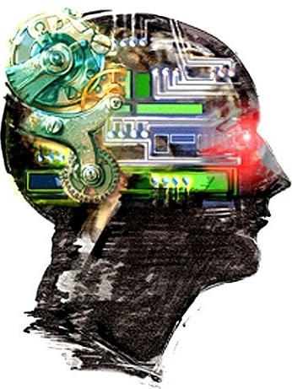  ArtifiCIal Intelligence  Introduction to AI | Abstract  The field of artificial intelligence, or AI, attempts to understand intelligent entities. Thus, one reason to study it is to learn more about ourselves.  Iftekhar Mahmud Towhid  CSTE 4103: Artificial Intelligence

Introduction to AI
  - What is artificial Intelligence
Artificial Intelligence (AI) is a branch of computer science and engineering that deals with intelligent behavior, learning, and adaptation in machines.

“AI is the study of complex information processing problems that often have their roots in some aspect of biological information processing. The goal of the subject is to identify solvable and interesting information processing problems, and solve them.”
-- David Marr

“Artificial Intelligence (AI) is the study of how to make computers do things which, at the moment, people do better.”
-- Elaine Rich, 1991

“AI is the art of creating machines that perform functions that require intelligence when performed by people”
-- Kurzweil, 1990

“AI is the branch of computer science that is concerned with the automation of intelligent behavior.”
-- Luger and Stublefield, 1993

"AI is a field of study that seeks to explain and emulate intelligent behavior in terms of computational processes"
--Schalkoff, 1990

  - Views of AI
Views of AI fall in four categories:
- Thinking humanly
- Thinking rationally
- Acting humanly
- Acting rationally

    - Acting Humanly: The Turing Test Approach
The Turing Test, proposed by Alan Turing (1950), was designed to provide a satisfactory operational definition of intelligence. Turing defined intelligent behavior as the ability to achieve human-level performance in all cognitive tasks, sufficient to fool an interrogator. Roughly speaking, the test he proposed is that the computer should be interrogated by a human via a teletype, and passes the test if the interrogator cannot tell if there is a computer or a human at the other end.

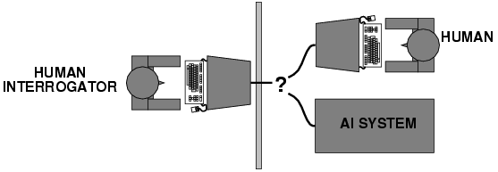

To pass the Turing test, the computer would need to possess the following capabilities:
- Natural language processing to enable it to communicate successfully in English (or some other human language).
- Knowledge representation to store information provided before or during the interrogation;
- Automated reasoning to use the stored information to answer questions and to draw new conclusions.
- Machine learning to adapt to new circumstances and to detect and extrapolate patterns.

Turing's test deliberately avoided direct physical interaction between the interrogator and the computer, because physical simulation of a person is unnecessary for intelligence. However, the so-called Total Turing Test includes a video signal so that the interrogator can test the subject's perceptual abilities, as well as the opportunity for the interrogator to pass physical objects "through the hatch." To pass the total Turing Test, the computer will need:
- Computer vision to perceive objects, and
- Robotics to move them about.

    - Thinking humanly: The cognitive modelling approach
- Method must not just exhibit behavior sufficient to fool a human judge but must do it in a way demonstrably analogous to human cognition.

- Requires detailed matching of computer behavior and timing to detailed measurements of human subjects gathered in psychological experiments.

- Cognitive Science: Interdisciplinary field (AI, psychology, linguistics, philosophy, anthropology) that tries to form computational theories of human cognition.

    - Thinking rationally: The laws of thought approach
- The Greek philosopher Aristotle was one of the first to attempt to codify "right thinking," that is, irrefutable reasoning processes. His famous syllogisms provided patterns for argument structures that always gave correct conclusions given correct premises. For example, "Socrates is a man; all men are mortal; therefore Socrates is mortal." These laws of thought were supposed to govern the operation of the mind, and initiated the field of logic.

- In AI, thinking AI involves formalizing “correct” reasoning using a mathematical model (e.g. of deductive reasoning).

- Logicist Program: Encode knowledge in formal logical statements and use mathematical deduction to perform reasoning.

Problems:
- Formalizing common sense knowledge is difficult.
- General deductive inference is computationally intractable.

    - Acting Rationally: Rational Agents
- An agent is an entity that perceives its environment and is able to execute actions to change it.

- Agents have inherent goals that they want to achieve (e.g. survive, reproduce).

- A rational agent acts in a way to maximize the achievement of its goals.

- True maximization of goals requires omniscience and unlimited computational abilities.

- Limited rationality involves maximizing goals within the computational and other resources available.

  - Foundations of AI
Many older disciplines contribute to a foundation for artificial intelligence:
- Philosophy: logic, philosophy of mind, philosophy of science, philosophy of mathematics
- Mathematics: logic, probability theory, theory of computability
- Psychology: behaviorism, cognitive psychology
- Computer Science & Engineering: hardware, algorithms, computational complexity theory
- Linguistics: theory of grammar, syntax, semantics

  - History of AI
    - Birth
- McCullouch and Pitts (1943): theory of neurons as logical computing circuits.
- Work in early 50’s by Claude Shannon and Turing on game playing and Marvin Minsky on neural networks.
- Dartmouth conference (1956)
- Organized by John McCarthy attended by Marvin Minsky, Allen Newell, Herb Simon, and a few others.
- Coined term “artificial intelligence.”
- Presentation of game playing programs and Logic Theorist.

    - Early Years
- Development of General Problem Solver by Newell and Simon in early sixties.
- Arthur Samuel’s late fifties work on learning to play checkers.
- Frank Rosenblatt’s Perceptron (1962) for training simple neural networks
- Work in the sixties at MIT lead by Marvin Minsky and John McCarthy
- Development of LISP symbolic programming language
- SAINT: Solved freshman calculus problems
- ANALOGY: Solved IQ test analogy problems
- SIR: Answered simple questions in English
- STUDENT: Solved algebra story problems
- SHRDLU: Obeyed simple English commands in the blocks world

    - Early Limitations
- Hard to scale solutions to toy problems to more realistic ones due to difficulty of formalizing knowledge and combinatorial explosion of search space of potential solutions.
- Limitations of Perceptron demonstrated by Minsky and Papert (1969).

    - Expert Systems
- Discovery that detailed knowledge of the specific domain can help control search and lead to expert level performance for restricted tasks.
- First expert system DENDRAL for interpreting mass spectrogram data to determine molecular structure by Buchanan, Feigenbaum, and Lederberg (1969).
- Early expert systems developed for other tasks: -MYCIN: diagnosis of bacterial infection (1975)
- PROSPECTOR: Found molybendum deposit based on geological data (1979)
- R1: Configure computers for DEC (1982)

    - AI Industry
- Development of numerous expert systems in early eighties.
- Estimated $2 billion industry by 1988.
- Japanese start “Fifth Generation” project in 1981 to build intelligent computers based on Prolog logic programming.
- MCC established in Austin in 1984 to counter Japanese project.
- Limitations become apparent, prediction of AI Winter
- Brittleness and domain specificity
- Knowledge acquisition bottleneck

    - Rebirth of Neural Networks
- New algorithms discovered for training more complex neural networks (1986).
- Cognitive modelling of many psychological processes using neural networks, e.g. learning language.
- Industrial applications:
- Character and hand-writing recognition
- Speech recognition
- Processing credit card applications
- Financial prediction
- Chemical process control

    - Recent Times
- General focus on learning and training methods to address knowledge-acquisition bottleneck.
- Shift of focus from rule-based and logical methods to probabilistic and statistical methods (e.g. Bayes nets, Hidden Markov Models).
- Increased interest in particular tasks and applications
- Data mining
- Intelligent agents and Internet applications (softbots, believable agents, intelligent information access)
- Scheduling/configuration applications (Successful companies: I2, Red Pepper, Trilogy)

